Lesson 17

**API Testing with Postman**

Level 1

**Using API for practice. Lesson 17.docx Create POST, GET, PATCH, and DELETE requests with:**

* **variables in the body of the request;**
* **variables in the request parameters;**
* **at least two tests for each request.**

**Schema:** https

**Base URL:** em.staging.api.onereach.ai/http/1b3bebb7-e882-4f1e-a74b-ee381bfa69d6

**Resource:** /users

**CREATE user**

**Request Body (JSON):**

name (required) - string, min 6, max 20 symbols

age (required) - number, min 1 max 100

gender (required) - string: only “male” or “female”

city (optional) - string

**Response body example:**

{

“name“:”pavel”,

“age“:”37”,

“gender“:”male”,

“city“:”Kyiv”,

“id“:”1505e6aa-0679-4258-860d-3a2284238446”

}

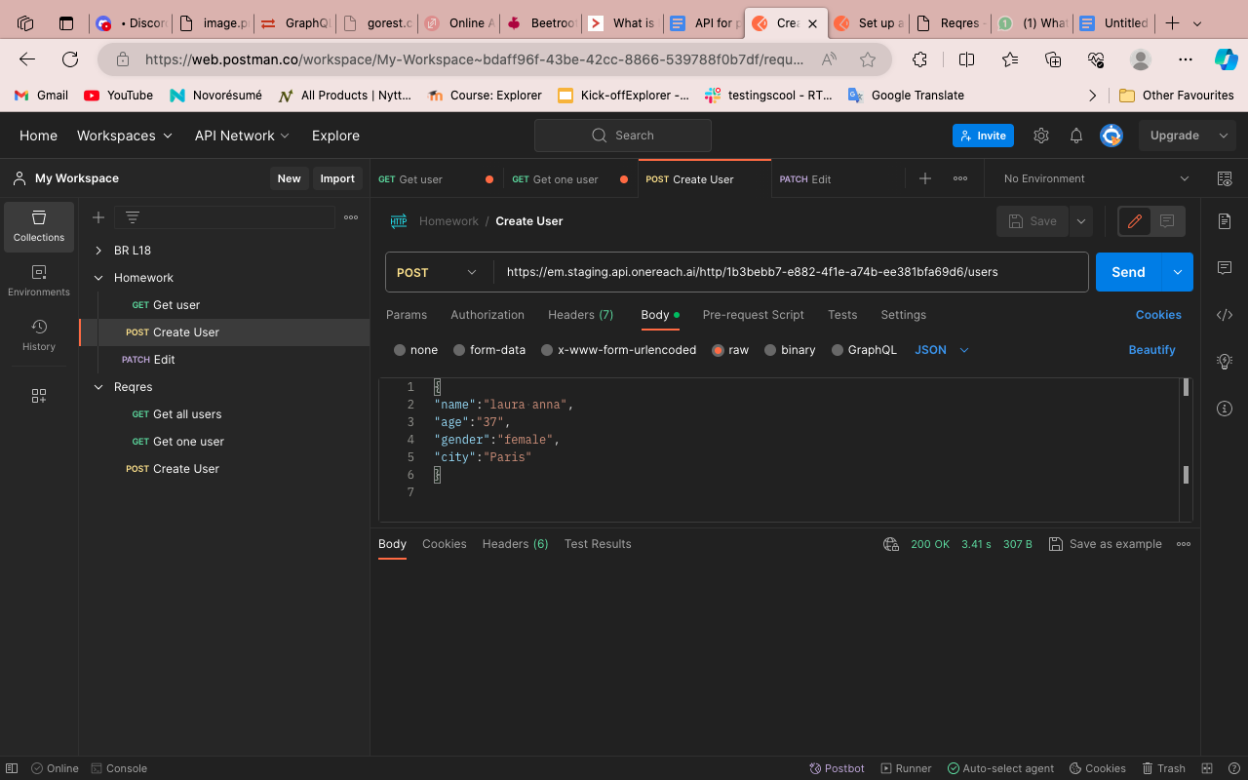

**2. GET User**

**Request Body:** none

**Request params:** id - string

**Response body example:**

{

“name“:”pavel”,

“age“:”37”,

“gender“:”male”,

“city“:”Kyiv”,

“id“:”1505e6aa-0679-4258-860d-3a2284238446”

}

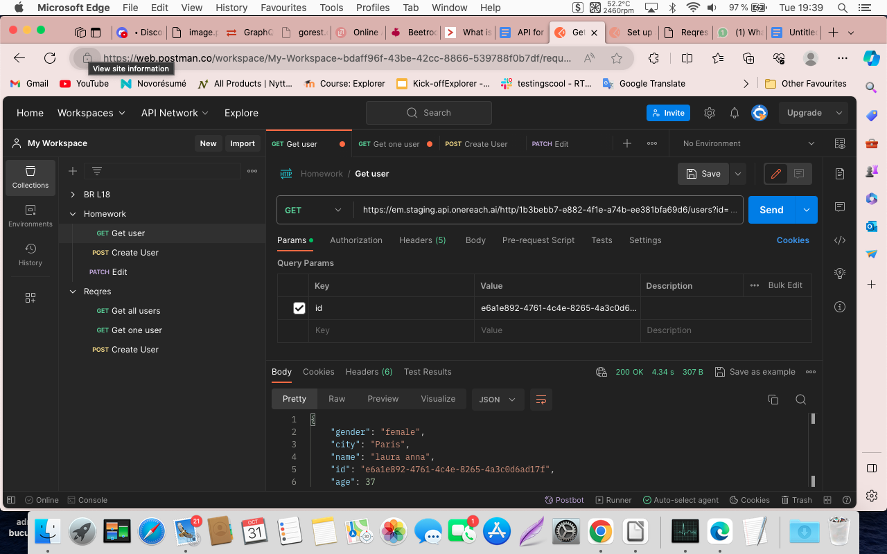

**3. EDIT user**

**Request Body (JSON):**

id (required) - string

name (required) - string, min 6, max 20 symbols

age (required) - number, min 1 max 100

gender (required) - string: only “male” or “female”

city (optional) - string

**Request params: none**

**Response body example:**

**{**

**User is updated**

**}**

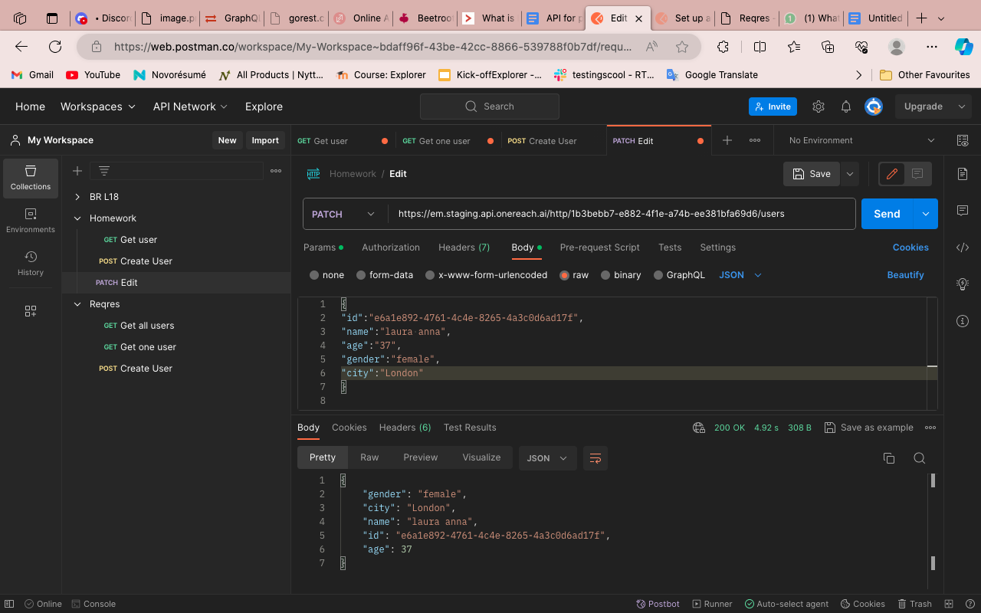

**4. DELETE user**

**Request Body:** none

**Request params:** id - string

**Response body example:**

{

user deleted

}

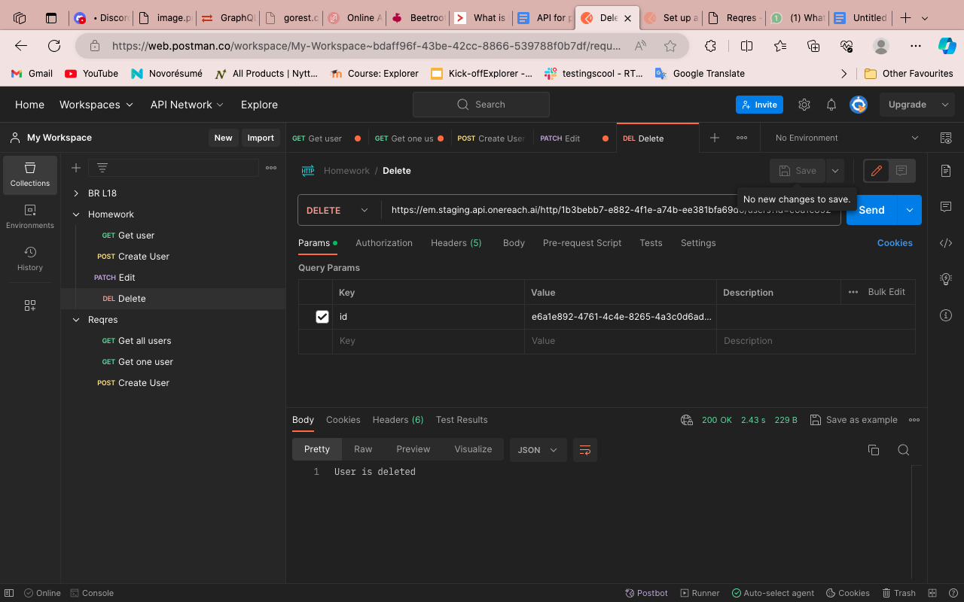

Level 2

**For each of the POST, GET, PATCH, and DELETE methods, create 1 positive and 1 negative test in the form of requests with the following:**

* **variables in the body of the request;**
* **variables in the request parameters;**
* **at least 2 tests for each request.**

**POST - positive test**

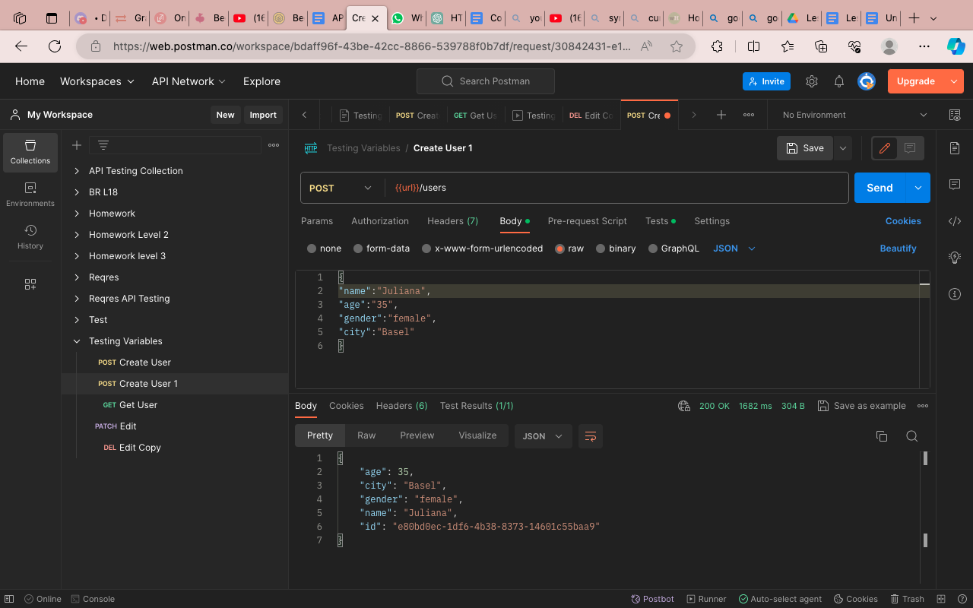

**Expected result: HTTP status 200 ok**

**POST-negative test**

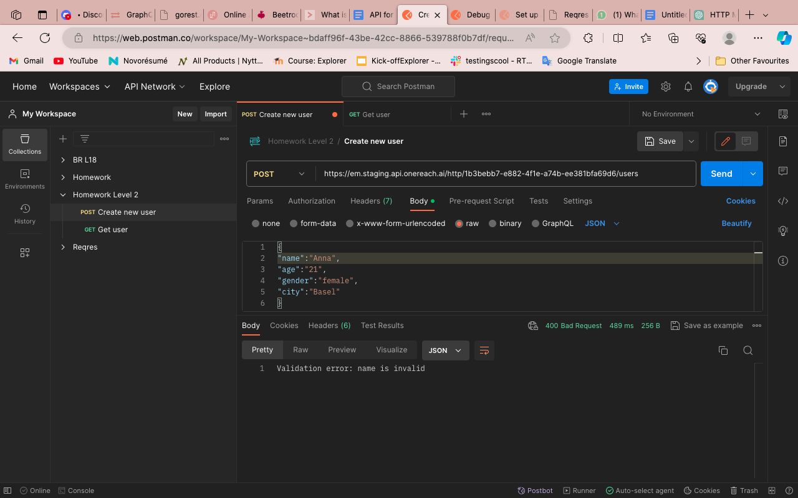

**Expected result: HTTP status 400 bad request**

**GET - positive test**

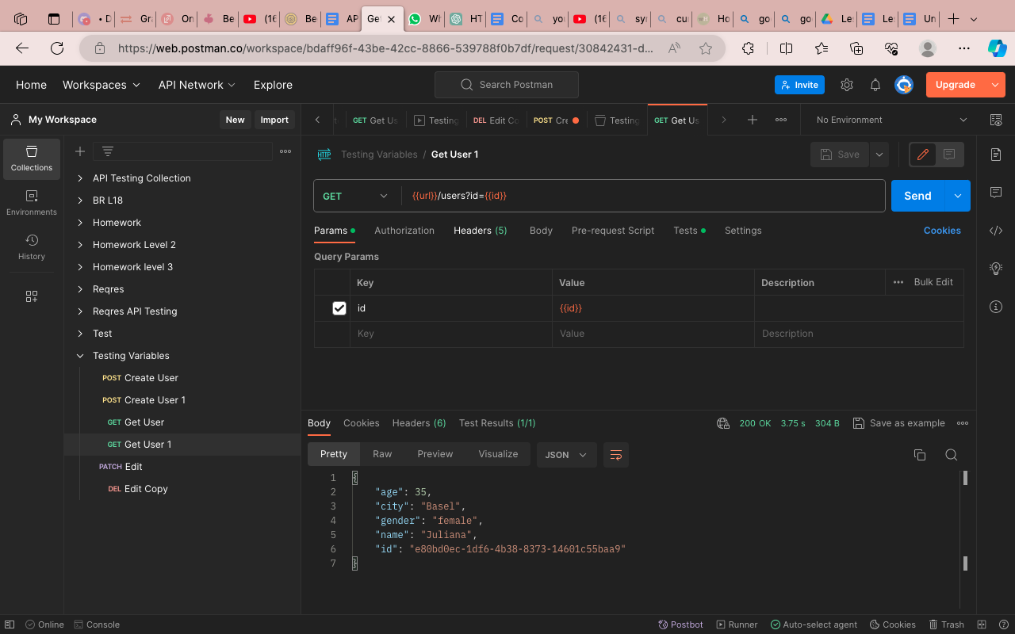

**Expected result: HTTP status 200 ok**

**GET - negative test**

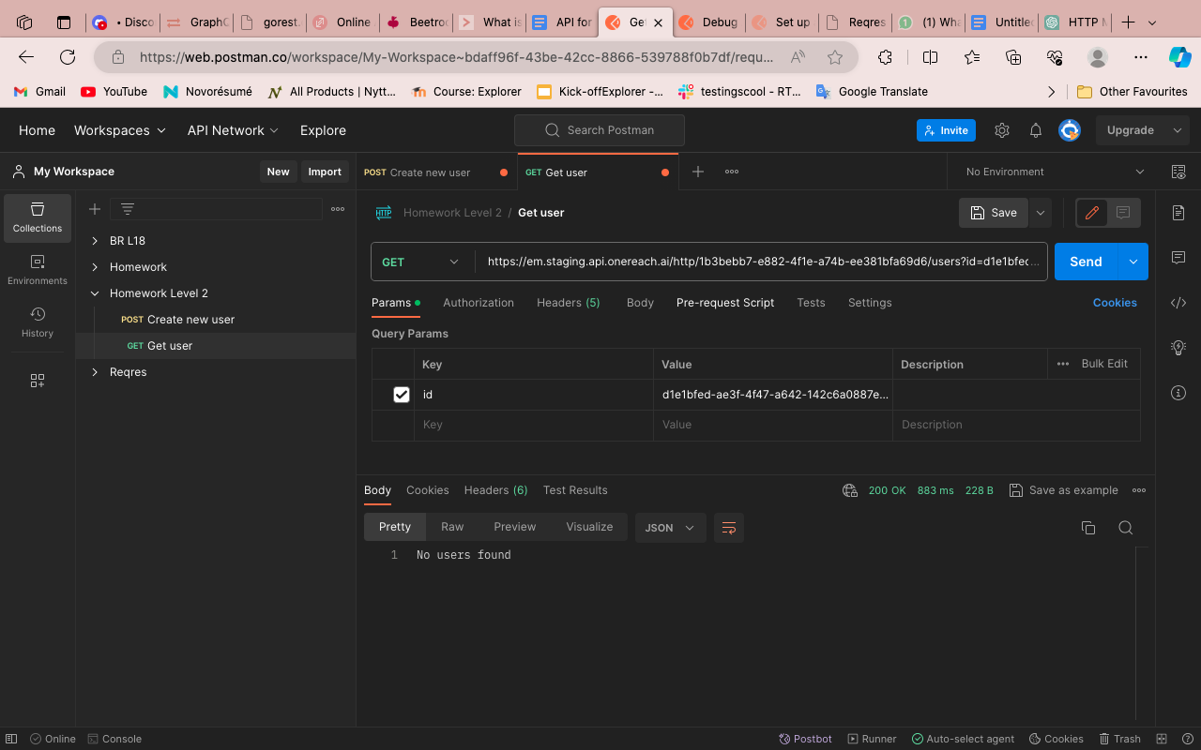

**Expected result: HTTP status 404 not found**

**Actual result: HTTP status 200 ok**

**PATCH - positive test (update resource)**

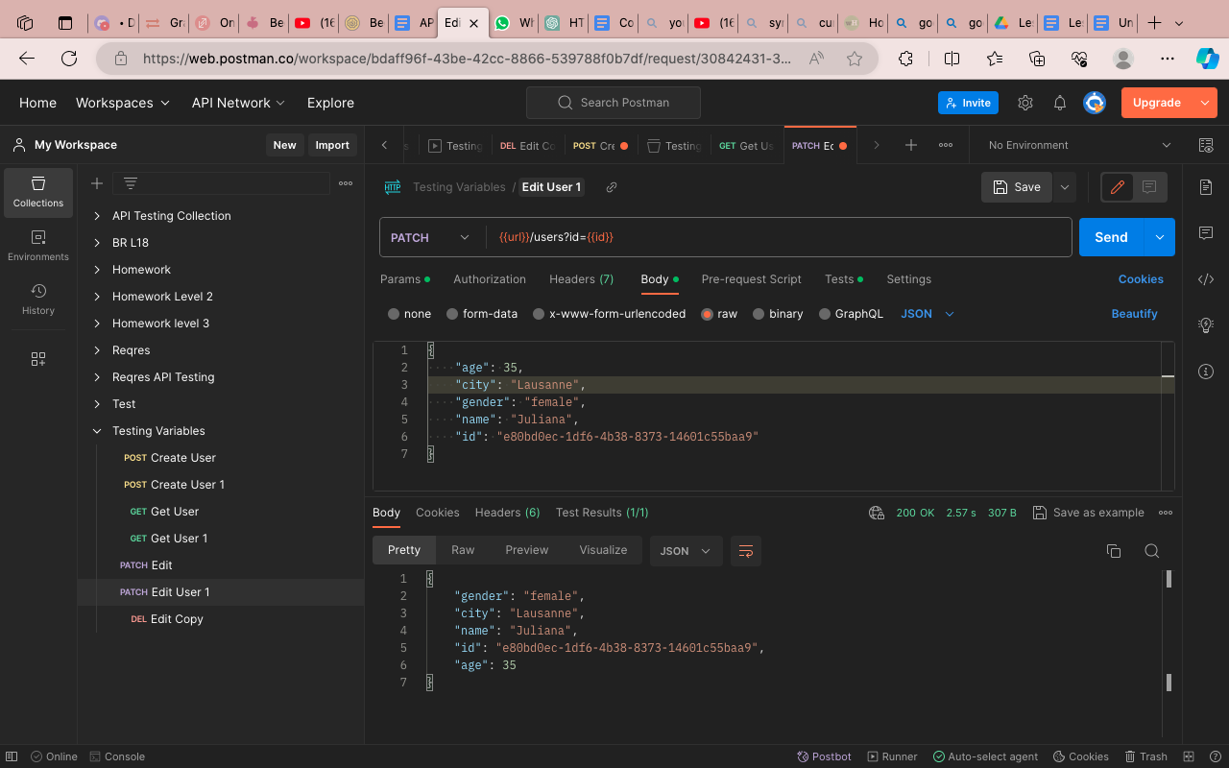

**Expected result: HTTP status 200 ok**

**PATCH - negative test (update resource; age=102)**

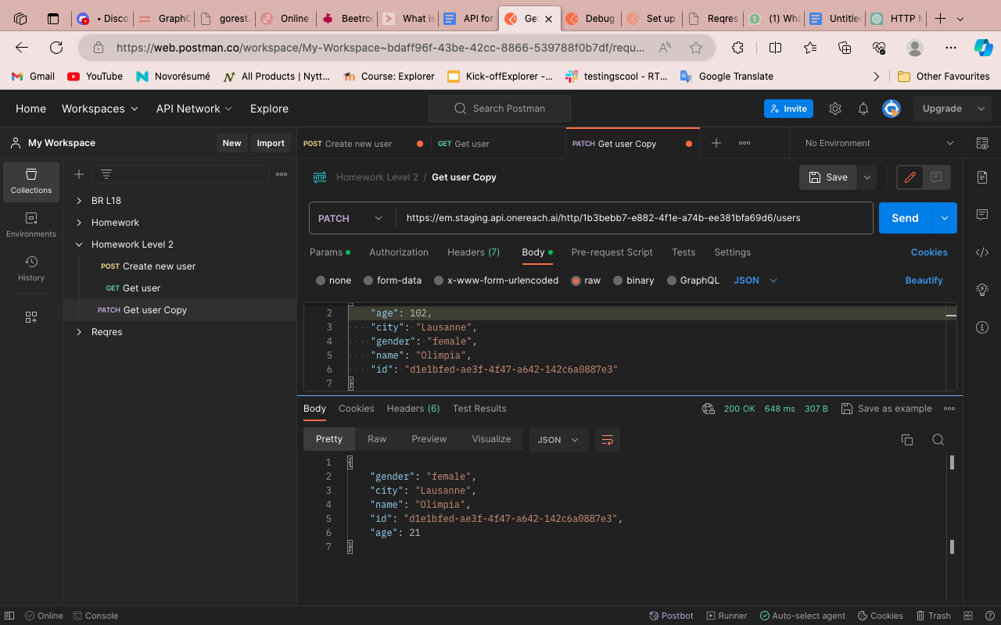

**Expected result: HTTP status 404 not found**

**Actual result: HTTP status 200 ok**

**DELETE - positive test**

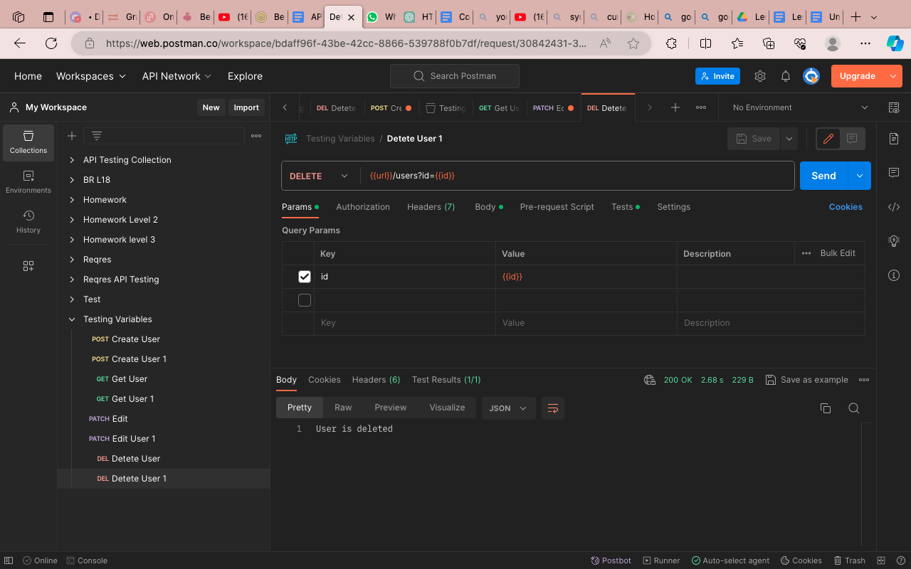

**Expected result: HTTP status 200 ok**

**DELETE - negative test**

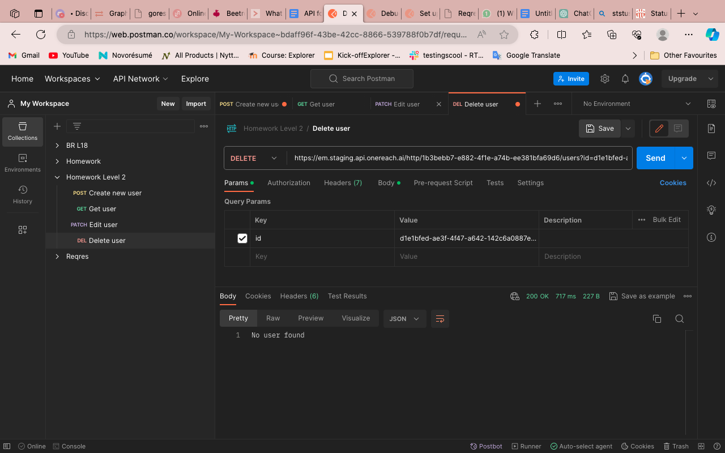

**Expected result: HTTP status 404 not found**

**Actual result: HTTP status 200 ok**

Level 3

**Create a collection of requests for each of the methods of the specified API (using variables and at least 2 tests for each request) — so that the data from the web service response for one request is used in subsequent requests.**

**The collection must be launched via the Collection runner with a positive passing of all tests.**

